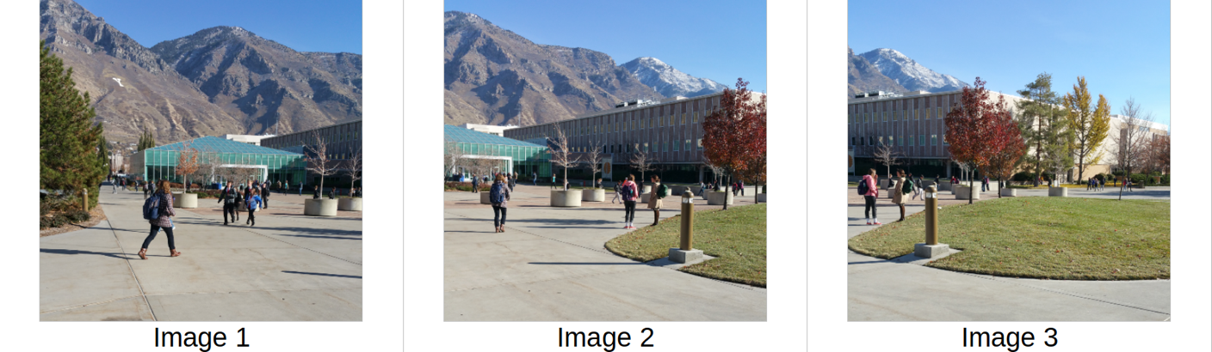

Part 1 – Keypoints

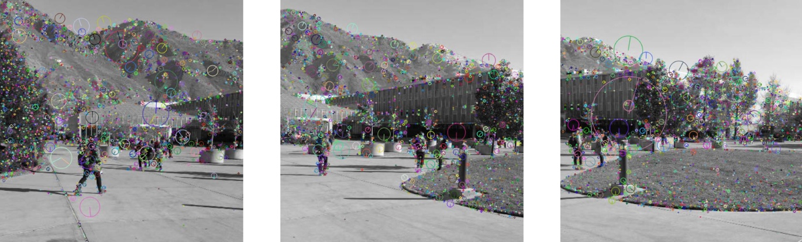

Part 2 – Matches
It’s okay if you place the images side-by-side, if the lines are different colors, and if you don’t display every point.
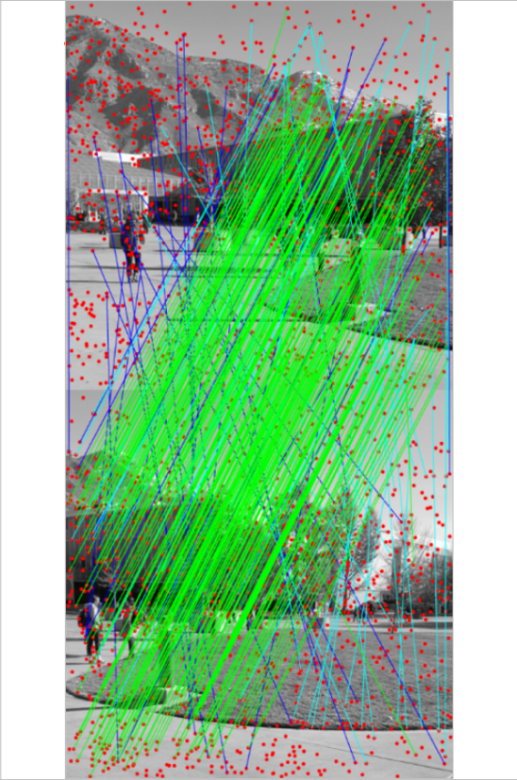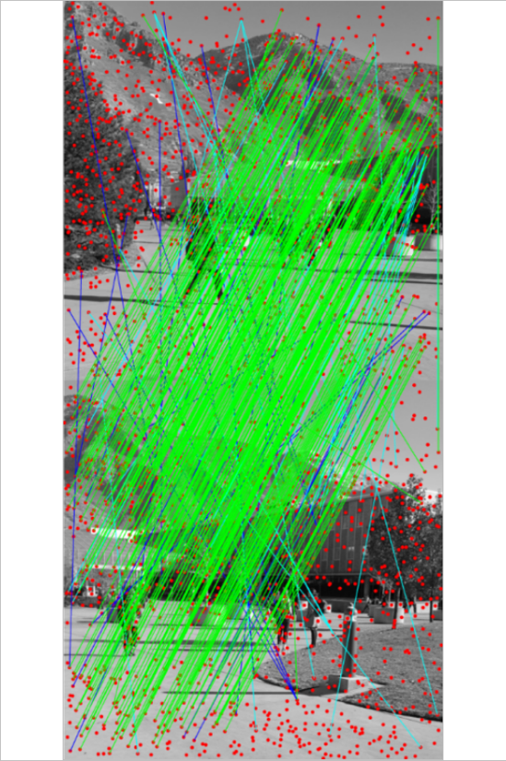
Part 4 – Composition
Visual of overlap (optional)
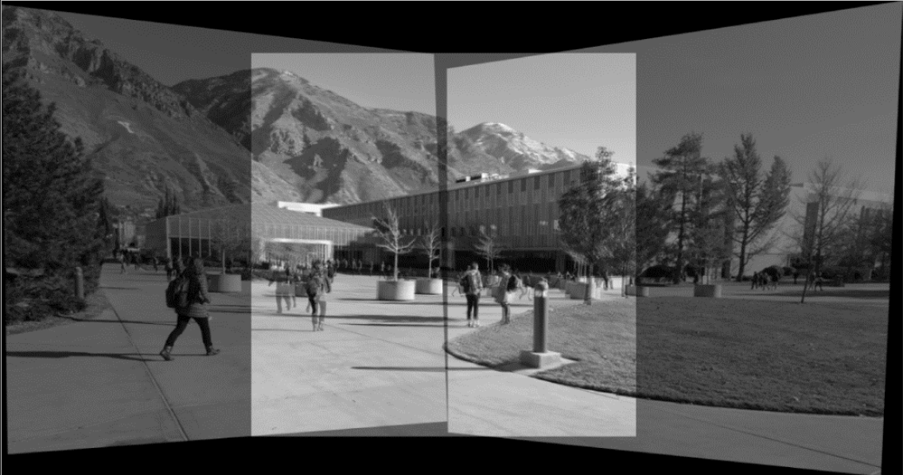

Final Output


